**Experiment No.: 4**

**Perform Remote login using Telnet server/ SSH server **

1. **Aim**:Perform Remote login using Telnet server/ SSH server using Linux Command Prompt.
2. **Objectives:** To make students understand the concept of and perform remote login using TELNET Server.
3. **Outcomes:** The learner will be able to

* Analyze the functioning of Telnet.
* Use the Telnet for building networks and performing remote login.
* Recognize the need for remote login.

1. **Hardware/Software required:** Telnet Server
2. **Theory:**

## Remote Login

A **shell**is a piece of software which provides a user interface to the computer's operating system, so that we may enter commands. There are many ways of accessing the shell on a remote computer from a local computer, including two programs called  **telnet** and **ssh**. The remote computer would run  **telnet** and/or **ssh** ***server*** software, and the local computer would run a **telnet** and/or **ssh** ***client*** software. We interact with the telnet ***client*** software on our local computer and it sends requests to the corresponding ***server*** software on the remote computer. Most multiuser computers run one of these server programs so that users can connect and use the machine.

As an aside, you have probably used and have on your home computer several other pieces of client software. You use an email client program (Outlook Express, Mozilla Thunderbird, Netscape's email client) to access an email server to retrieve and send mail. Your web browser contains a web client which makes requests for html and other documents from a web server.

The shell access client software (the one running on your local computer) gives you a terminal **window** that along with a keyboard behaves the same as the old monitors used in the original terminals.

Shell access, such as through the **ssh** or **telnet** program is a simple and ***low-bandwidth*** way of connecting to a remote computer. Low-bandwidth means that only a small amount of information is transferred per second. It doesn't require a fast connection to the remote computer, and a client program can be run from any computer that is connected to a network, even if both computer are using different Graphical User Interface's (Windows, MAC OS, X-Windows etc.) or not using a GUI at all.

**Telnet** is a protocol that allows you to connect to remote computers (called hosts) over a [TCP/IP](https://kb.iu.edu/d/abkr) network (such as the internet). Using telnet client software on your computer, you can make a connection to a telnet server (i.e., the remote host). Once your telnet client establishes a connection to the remote host, your client becomes a virtual terminal, allowing you to communicate with the remote host from your computer. In most cases, you'll need to log into the remote host, which requires that you have an account on that system. Occasionally, you can log in as guest or public without having an account.

## Steps to Install and Use Telnet in Ubuntu

Step 1: Firstly, open the “Terminal” window by pressing “Ctrl + Alt + T”. In the figure, you may see “$” that signifies that you are not logged in as a root user.

So, I”ll write “sudo apt-get install telnetd” and press enter. If you are a root user, then you don’t need to write sudo in Ubuntu. “telnetd” is a daemon that gets invoked by “inetd” or its extension “xinetd”, both are the internet servers.

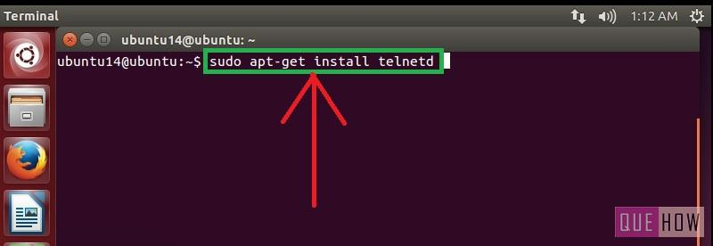

Step 2: Then you are asked to enter the user password and then press enter. Processing will start as soon as you press enter. After this, I have noticed a line “274 KB additional disk space will be used” on the terminal screen.

You may also observe some sort of a message like this and then you”ll be asked to continue or not. Just write “y” and then press enter to continue.

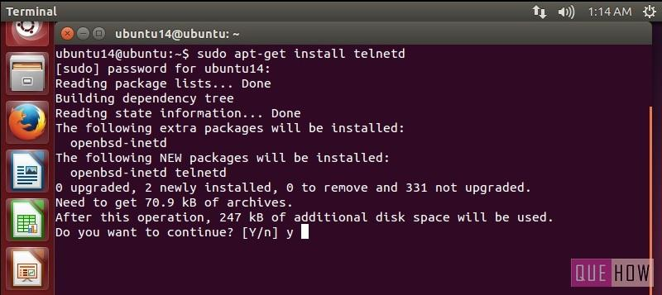

Step 3: Now when you are done with it, restart “inetd”. Type “sudo /etc/init.d.open-bsd-inetd restart”.

“inetd” is daemon used for dealing with incoming network and it is responsible for deciding which program to run when a request comes.

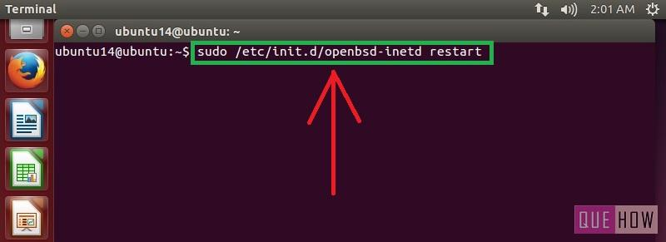

Step 4: To ensure “inetd” is started, press enter after writing the above command.

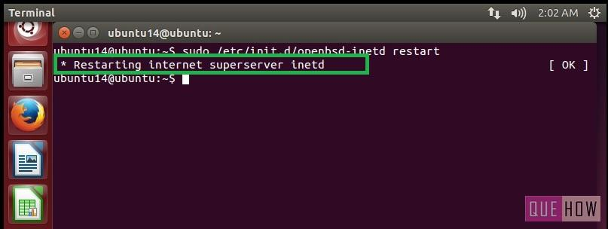

To connect with any remote client:

Step 5: Just type:“telnet hostipaddress”. For an example: “telnet 122.175.140.221” and press enter.

Step 6: Then you”ll see, it is connected to “host ip address”. For security reasons, you are required to provide “username” and “password” as well.

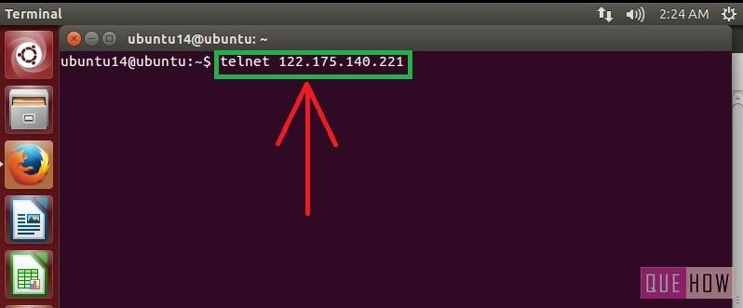

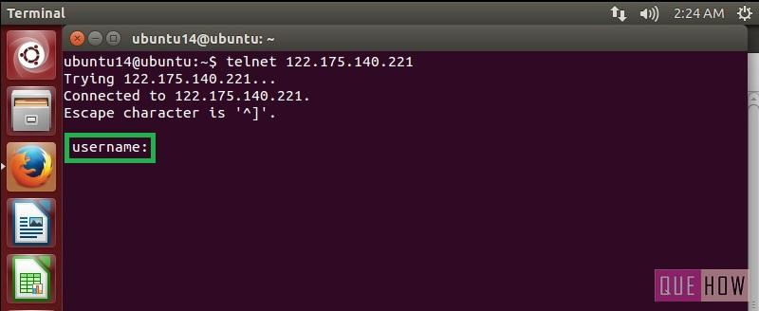

1. **Output Analysis:**

(Students should write output analysis based on the working of different topology and different networking devices used in simulation. Specify each scenario explicitly with output analysis)

1. **Additional Learning:**

(Students should write additional learning on their own based on what additionally they learnt after performing the experiment)

1. **Conclusion :**

(Students should write conclusion on their own)

1. **Viva Questions:**

* State the steps to install Telnet.
* Telnet operates at which layer of OSI model.

1. **References:**
   1. A.S. Tanenbaum, “Computer Networks”, Pearson Education, (4e)
   2. B.A. Forouzan, “Data Communications and Networking”, TMH (5e)